Kingdom of Saudi Arabia  Ministry of Education  Hafr Al Baten Educational Directorate for boys  Tarbeat Al –Ajial International Schools |  |  |  |   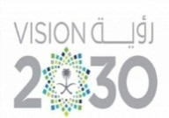 |  |  | Date: 2025 / /  Subject: Computer  Class.: 4  Time: 40 minutes
……………… |  | Seat Number |  | ……………………………………….. |  |  |  | Student’s Name
Mid-Term Exam (1st Semester) 2025/2026
Sign. | Consultative Name |  | Sign. |  | Corrector’s Name | Marks in letters |  |  | Marks  in numbers
 |  |  |  |  |  |  |  |  | 20

Q1: Match the following:
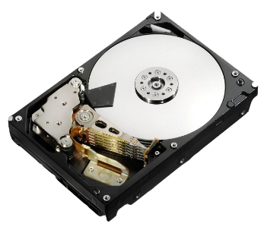 | CPU
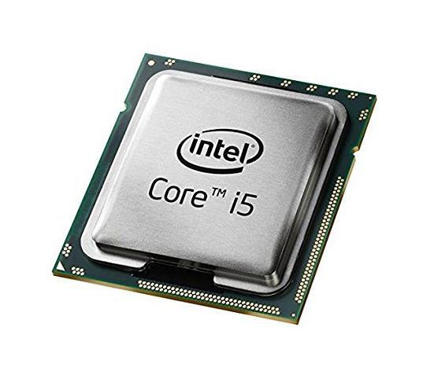 | Hard Disk
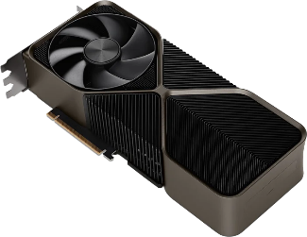 | RAM
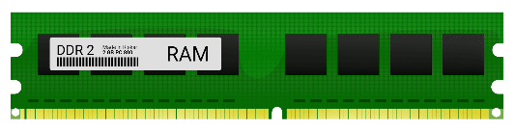 | GPU

Q2: write the correct name of each part:

Computer | Ethernet Cable | Router
Ethernet Port | Laptop | Modems

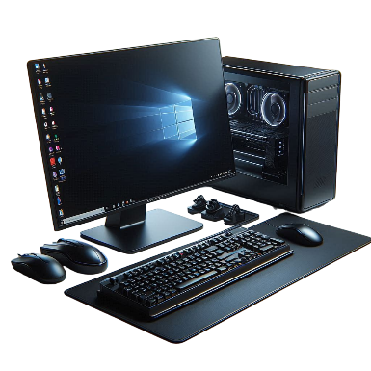 | …………………………  Computer  …………………………  ………………………… | 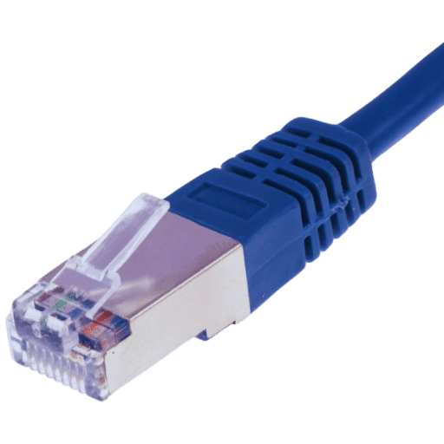 | …………………………  Ethernet Cable  …………………………  …………………………
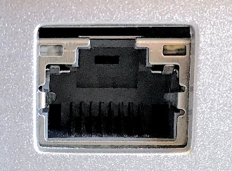 | …………………………  Ethernet Port  …………………………  ………………………… |  | …………………………  Router  …………………………  …………………………
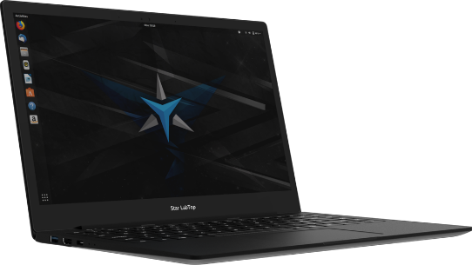 | …………………………  Laptop  …………………………  ………………………… | 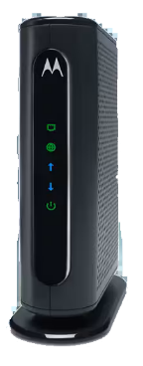 | …………………………  Modems  …………………………  …………………………
Good Luck

